Cardiac care worksheet

- Read the article link here: https://www.nursingtimes.net/clinical-archive/cardiovascular-clinical-archive/cardiac-system-1-anatomy-and-physiology-29-01-2018/
Make notes on the article for discussion.

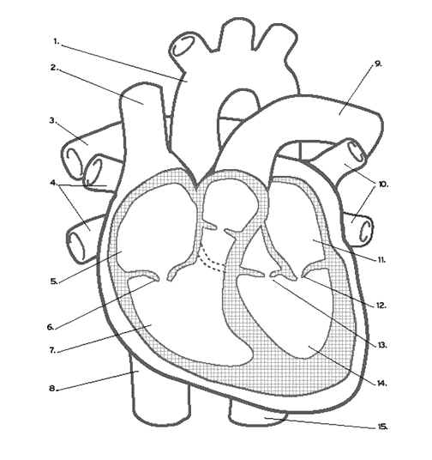
- Label the diagram below…
1.
2.
3.
4.
5.
6.
7.
8.
9.
10.
11.
12.
13.
14.
15.

Bullet point the cardiac cycle-

What is your understanding of the Frank-Starling law?

This PQRST complex is the normal sinus rhythm shown on an ECG.

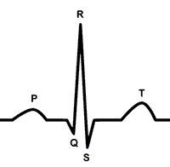

What changes would you notice on an ECG with-

- AF

- Tachycardia

- Bradycardia

- NSTEMI

- STEMI

Do you have any ways of remembering where to place ECG leads?

What cardiac conditions have you heard of in practice so far?

What cardiac drugs have you heard of in practice so far?

In your own words what is blood pressure and how would you explain this to a patient?

Write a short reflective account on a patient scenario for discussion in the session…

