Minor injuries worksheet

- Read the NICE guidelines on human and animal bites:
https://cks.nice.org.uk/topics/bites-human-animal/

What are the potential complications of a bite wound?

What immunisation are people recommended to have up to date when they attend with a bite wound?

Do we give this immunisation to all bite wounds? Explain why to your answer.

For human bite wounds what other infectious diseases do we need to consider?

What is a tetanus prone wound?

Would you immediately stitch a dog/cat bite?

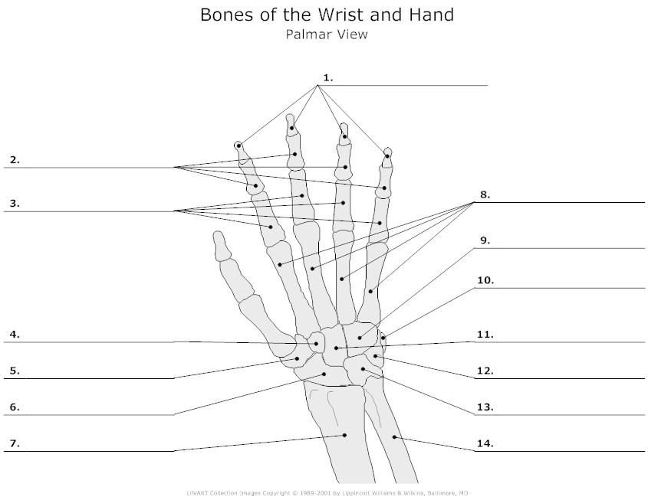
Label this diagram…

Name some common injuries to the wrist and hand below.

What is the management advice for a sprain?

If a patient has a sprained ankle what other things may we need to consider? Think about ADL’s.

Back pain
What is sciatica?

Name some common causes of back pain…

Name some treatment options of back pain…

Give some characteristics of back pain- what is the characteristic of sciatica?

Name the cranial nerves and their functions
- Cn1
- Cn2
- Cn3
- Cn4
- Cn5
- Cn6
- Cn7
- Cn8
- Cn9
- Cn10
- Cn11
- Cn12
When might we need to check the cranial nerves?

Name some common eye conditions.

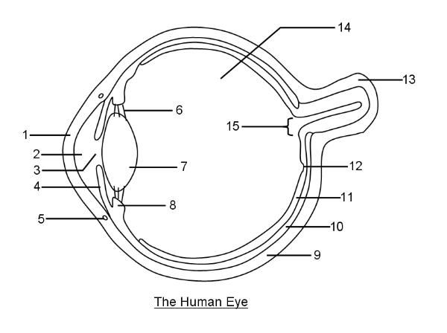
Label the diagram…

Reflections: Write a reflection on a consultation/situation regarding a minor injury. Use the Gibbs cycle and concentrate on emotional intellegence and give detail on feelings that guided decisions.

Lastly read the article and answer the questions on the padlet link below.
https://www.independentnurse.co.uk/clinical-article/assessment-and-management-of-common-musculoskeletal-injuries/219339/

https://padlet.com/ku70450/37uxid6n94s19fwq

