Asthma IPL worksheet

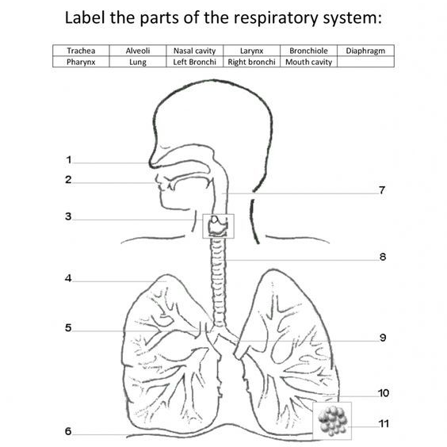
- Label the diagram below-

- In your own words, what is asthma?

- List some asthma triggers…

- What are some asthma medications?

- What do we do in primary care to monitor patients with asthma?

- How would you recognise someone is having an asthma attack?

- Bullet point actions you would take to manage someone having an asthma attack… Use guidelines.

- What activities of daily living may be compromised for an under 18 year old with severe asthma?

- Reflections- write a brief reflection on caring for a patient with asthma- adult or child.

- Read this article and make notes for discussion in the session: https://ebm.bmj.com/content/early/2020/09/02/bmjebm-2020-111506

